Power supply og støj.
Begreber:
Power Snoop,
Ground Bounce

Kapitel 6.2

$$T_{D}=X·\sqrt{L·C}$$
$$f_{D}=\frac{1}{T_{D}}$$
$$ω_{D}=2π·f_{D}=2π·\frac{1}{X·\sqrt{L·C}}$$
Resonance frekvens?
$$f_{0}=\frac{1}{2π·\sqrt{L·C}}$$
Kan ikke lige se forholdet

Design for power supply.
- Maksimal støj fra supply? Power droopen, ∆V, er den vi kan designe for.
- Maksimal strøm, ∆I, som må gå gennem?
- $Z_{max}=\frac{∆V}{∆I}$
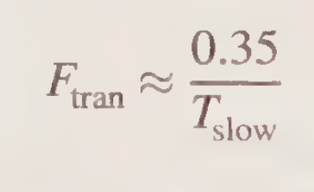

Frekvens karakteristik af input impedansen af en power supply
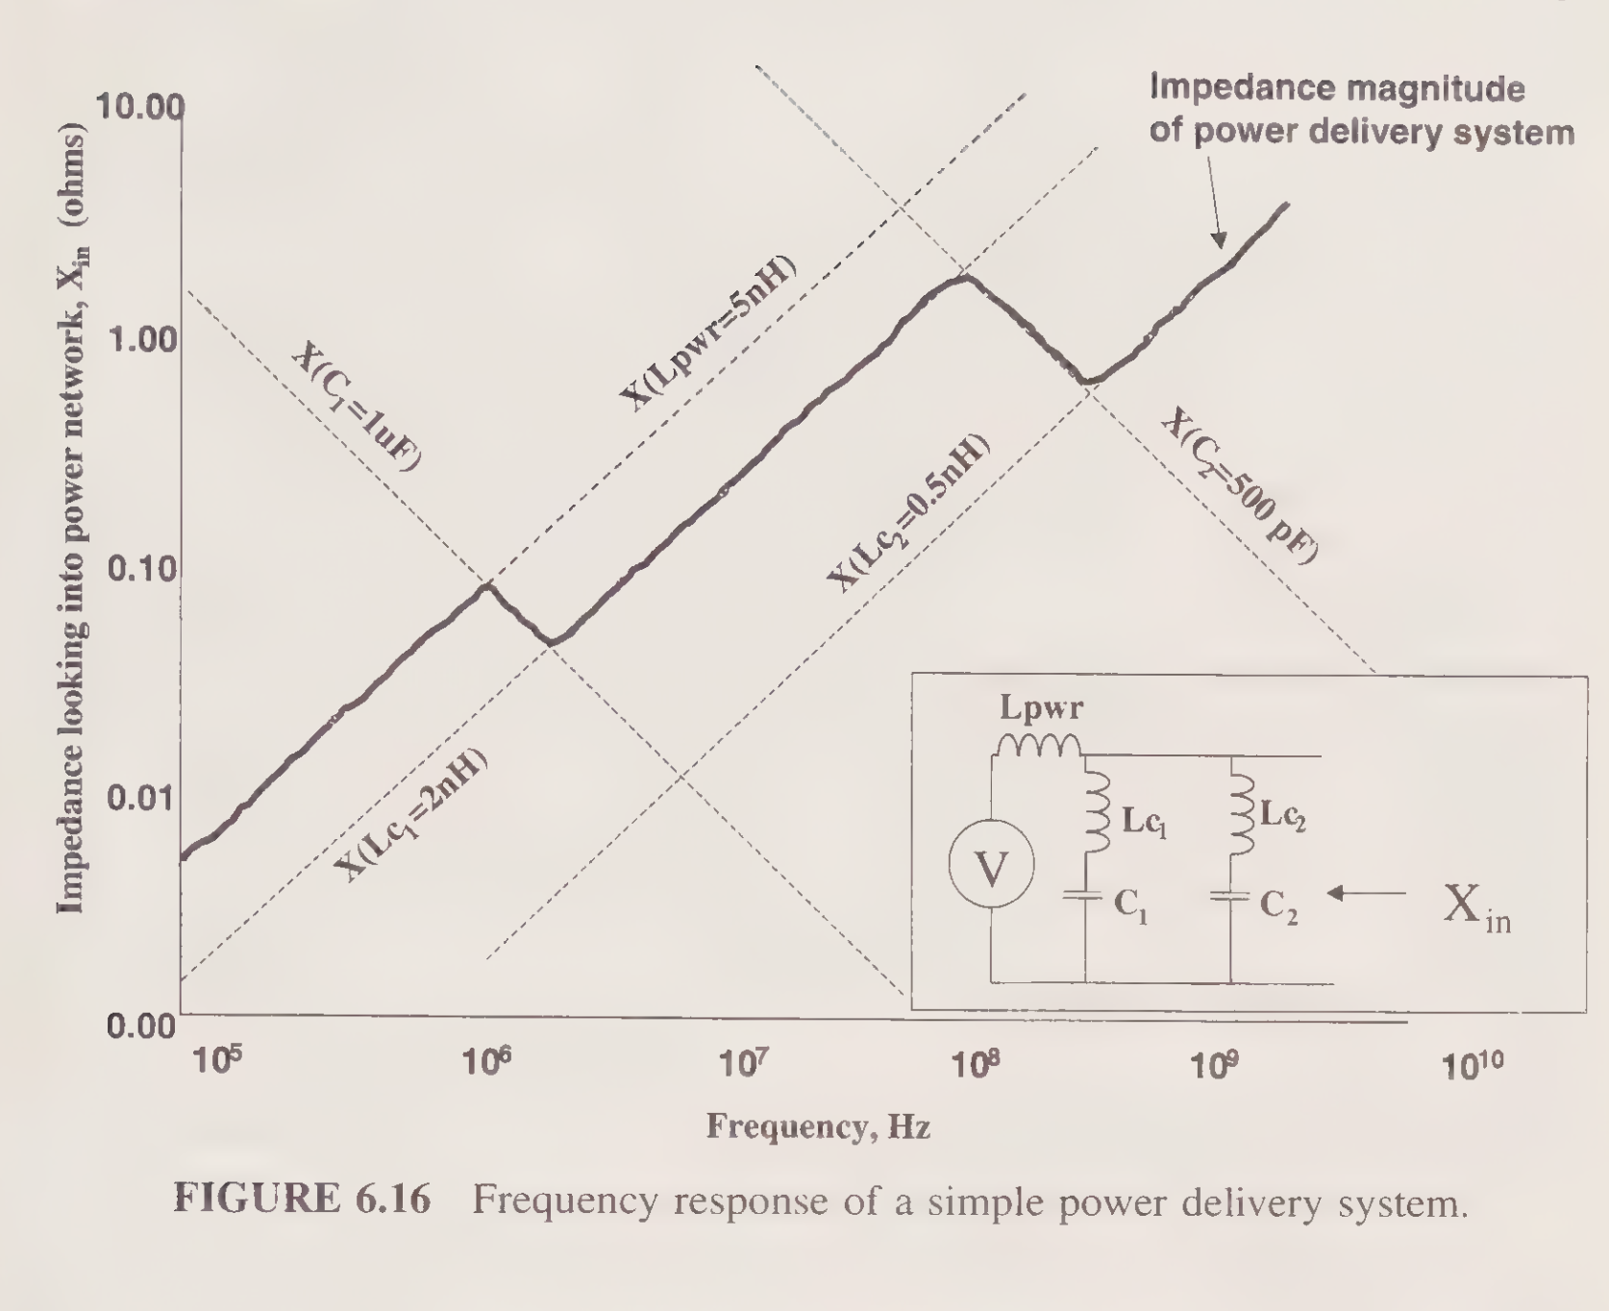

Opgaver

Opgave 3.1
Consider the two-line system in Figure 1. Assume perfect impedance match for both lines: $Z_{01}=Z_{02}=Z_{S1}=Z_{S2}=Z_{t1}=Z_{t2}$, (So no trouble with reflections).
Assume for line 1 (aggressor line) that at t = 1 ns a pulse rises from zero to $V_{O}=2V$, with $T_{r}=100ps$. Line 2 (victim line) is constant at $V_{S2}=2V$ ( a DC value ). The length of both lines is X = 5cm, and assumed to be loss-free with the following inductance and capacitance matrices:
$definer:L=\left[\begin{matrix}400 & 80 \\ 80 & 400\end{matrix}\right]\frac{nH}{m}, C=\left[\begin{matrix}80 & 10 \\ 10 & 80\end{matrix}\right]\frac{pF}{m}$
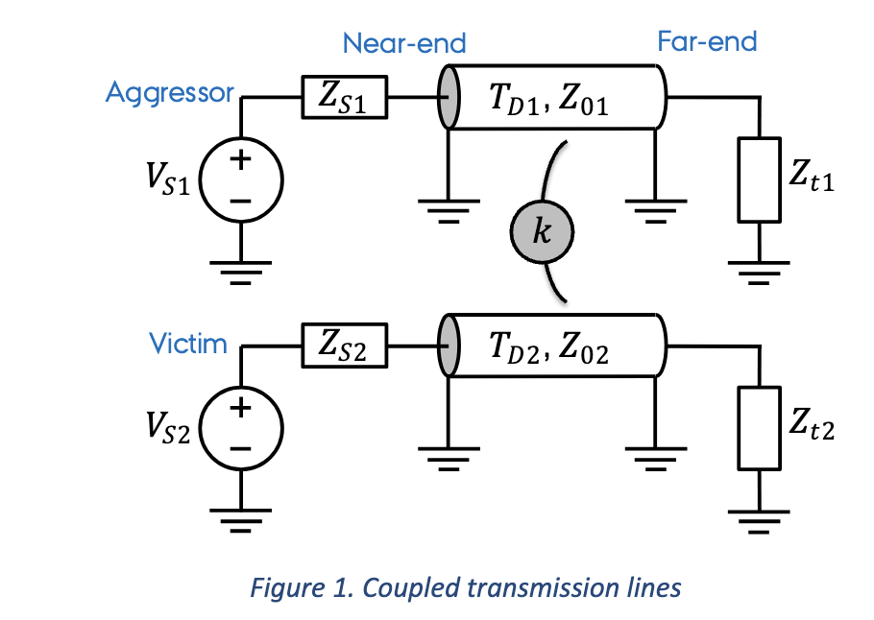

- Calculate the characteristic impedance and time delay for the transmission lines (as single lines).
$T_{D}=0,05m·\sqrt{L\left[1\right]\left[1\right]·C\left[1\right]\left[1\right]}=0,05·m·\sqrt{\frac{32000·nH·pf}{m^{2}}}$
$T_{D}=0,05·\sqrt{32000·{10}^{-9}·{10}^{-12}}=2,56·\frac{{10}^{-8}}{2^{\frac{13}{2}}}≈2,828·{10}^{-10}$
============
$T_{D}=282,8ps$
============

- Calculate the near- and far-end crosstalk pulse by using the formulas in the textbook (figure 3.4).
$V_{near}\left(V_{input}, L, C\right)≔\frac{V_{input}}{4}·\left(\frac{L\left[2\right]\left[1\right]}{L\left[1\right]\left[1\right]}+\frac{C\left[1\right]\left[2\right]}{C\left[1\right]\left[1\right]}\right)$
$V_{far}\left(V_{input}, L, C, X, T_{r}\right)≔-\frac{V_{input}·X·\sqrt{L\left[1\right]\left[1\right]·C\left[1\right]\left[1\right]}}{2·T_{r}}·\left(\frac{L\left[2\right]\left[1\right]}{L\left[1\right]\left[1\right]}-\frac{C\left[1\right]\left[2\right]}{C\left[1\right]\left[1\right]}\right)$
=====================
$V_{near}\left(a;L;C\right)=\frac{26}{160}V$
$V_{far}\left(V;L; C;X;T_{r}\right)=-\left(\frac{3·2V·0,05m·\sqrt{\frac{32000·nH·pF}{m^{2}}}}{80·100·{10}^{12}s}\right)$
$V_{far}\left(V;L; C;X;T_{r}\right)=-\left(\frac{\frac{6}{20}V·\sqrt{32000·{10}^{-9}·{10}^{-12}HF}}{80·100·{10}^{12}s}\right)$
$V_{far}\left(V;L; C;X;T_{r}\right)=-\left(\frac{\frac{6}{20}V·\sqrt{32000·{10}^{-9}·{10}^{-12}HF}}{80·100·{10}^{12}s}\right)=-\left(\frac{3·\sqrt{\frac{HF}{31250000000000000}}·V}{80000000000000000·s}\right)$
$V_{far}\left(V;L; C;X;T_{r}\right)=-\left(6,7·{10}^{-17}·\frac{\sqrt{HF}·V}{s}\right)$

Draw the voltage curves of the near- and far-end crosstalk pulses.
Begge enderne af victim linen er termineret i ground ligeledes… Derfor må jeg gå ud fra at input siden har en karakteristisk impedans og output siden har den samme karakteristiske impedans.
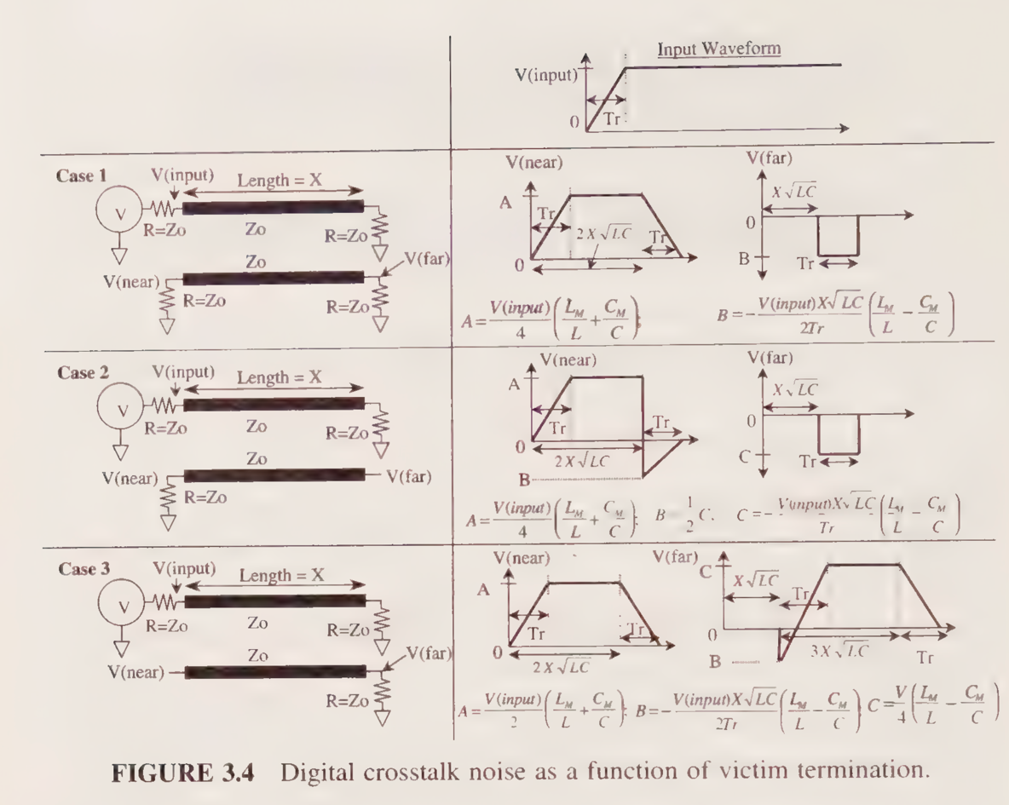
$T_{D}=282,8ps$
$\frac{T_{D}}{T_{r}}≈3$
Med betingelserne beskrevet, så må det være en case 1, at jeg skal modellere for.

- Calculate the near- and far-end crosstalk voltages in the case where $Z_{S2}=40Ω$ and $Z_{t2}=1kΩ$.

- Create an equivalent LC-circuit model of the coupled transmission line system from part 1.
$$C_{m}=C\left[1\right]\left[2\right]·0,05m=0,5·pf$$
$$N_{seg}≥10·\frac{282,8}{100}·\frac{ps}{ps}=28,28$$
$$N_{seg}=29$$

- Simulate in LTSPICE the two cases calculated in part 1. Probe the signals at the near- and far-end for both transmission lines. Do the simulations correlate with the calculated results in part 1?
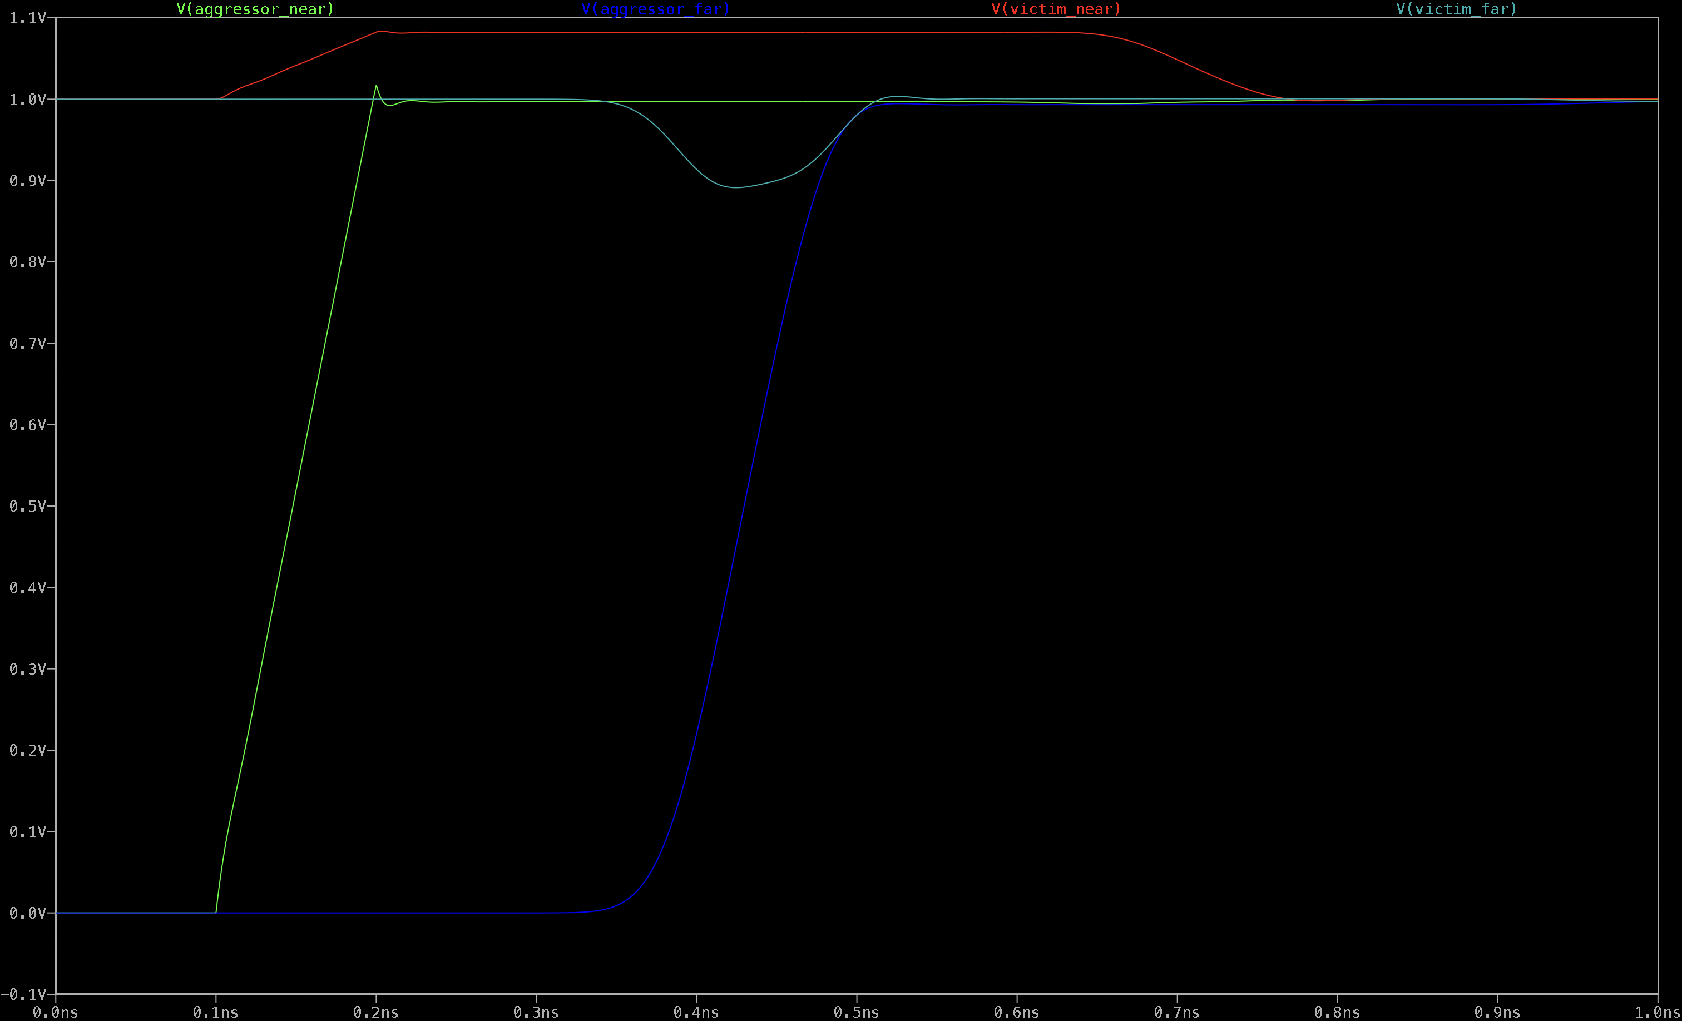

Opgave 4.1
Consider the two-line system in Figure 1, (note that the victim line is also actively driven here). The loading is set for an impedance of $Z_{t1}=Z_{t2}=65Ω$ and the drivers have an impedance of $Z_{S1}=Z_{S2}=40Ω$. The drivers, $V_{S1}\&V_{S2}$, can both toggle between 0 V and 2 V, with an edge rate of $T_{r}=100ps$.

The length of the coupled transmission lines is X = 5 cm, and assumed to be loss-free with the following
$$Definer: L=\left[\begin{matrix}274 & 39,4 \\ 39,4 & 274\end{matrix}\right]\frac{nH}{m}, C=\left[\begin{matrix}114 & 3,94 \\ 3,94 & 114\end{matrix}\right]\frac{pf}{m}$$

Theory
- Calculate the odd & even mode characteristic impedance and time delay for the transmission lines.
$$A^{2}+b=x$$

$$Skriv ligningen her.$$

- Determine the far-end (load) reflection coefficients for odd & even mode, and calculate the expected amplitude seen by the load caused by the first reflection (for later comparison).
- Calculate the optimal m- and T-termination resistor values which can eliminate the reflections.

Simulation
- Create an equivalent LC-circuit model of the coupled transmission line system from part 1.
- ﻿﻿﻿Set up the full circuit in LTspice starting with the initial load values and simulate both odd & even mode signals. Observe the signals, do the initial amplitudes match what you expected in part 1.2?
- Replace the load with r- and T-termination network respectively and simulate odd & even mode again. Do they remove the reflections as expected?

Note: The coupling between two inductors in LTSPICE is done by adding a command, called a "SPICE directive", for each pair. E.g. "K L1 L2 factor" with 'factor' being your calculated coupling factor.

$$Z_{even}=\sqrt{\frac{L_{even}}{C_{even}}}=\sqrt{\frac{L_{11}+L_{12}}{C_{11}-C_{12}}} \left(3.31\right)$$
$$Slet definitioner:$$

Opgave 5

Theory
Consider the symmetrical stripline given in Figure 1, which has the following data
$define:W_{con}=0,2·{10}^{-3}m, H_{di}=0,5·{10}^{-3}m, t_{con}=17·{10}^{-6}m, μ_{copper}=4π·{10}^{-7}\frac{H}{m}, σ_{copper}=5,8·{10}^{7}\frac{S}{m}, ρ=\frac{1}{σ_{copper}}$
We start off without giving a frequency, nor specifying a distance. Use the formulas given in the book, specifically those on page 81, equation 4.9 for the AC resistances.
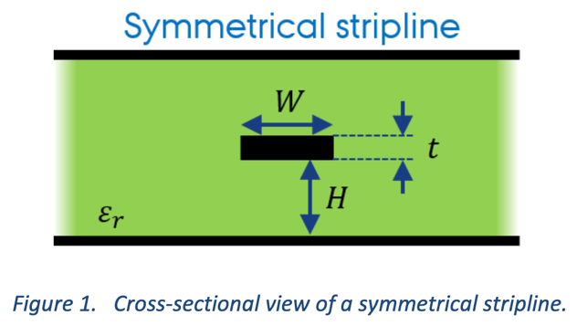
$lossratio\left(W, H\right)≔block\left( var, var:\frac{1}{2},if\frac{W}{H}<var then return\left(1\right), 0,94+\frac{132·W}{1000·H}-\frac{62}{10000}·\frac{W^{2}}{H^{2}}\right)$
$R_{ground}\left(W_{mat},H_{mat}, μ_{mat}, ρ\right)≔\frac{\frac{W_{mat}}{H_{mat}}}{\frac{W_{mat}}{H_{mat}}+5,8+0,03·\left(\frac{H_{mat}}{W_{mat}}\right)}·\frac{\sqrt{π·μ_{mat}·ρ}}{W_{mat}}$

$$\frac{1}{π^{2}}·\ln\left(147,8\right)≈0,5062$$
$$\frac{\sqrt{π·μ_{copper}·f·ρ}}{W_{con}}$$
$$π·μ_{copper}·f·ρ≈\left(5,417·{10}^{-8} f·μ_{0}\right)·\left(\frac{m}{S}\right)=\left(6,81·{10}^{-14} f\right)·\left(\frac{T·m^{2}}{A·S}\right)$$
$R_{signal}=lossratio\left(W_{con}, H_{di}\right)·\left(\frac{1}{π}+\frac{1}{π^{2}}·\ln\left(4·π·\frac{W_{con}}{t_{con}}\right)\right)·\frac{\sqrt{π·μ_{copper}·F·ρ}}{W_{con}}$
$R_{signal}=lossratio\left(W_{con}, H_{di}\right)·\left(\frac{1}{π}+\frac{1}{π^{2}}·\ln\left(147,8\right)\right)·\frac{\sqrt{\left(6,81·{10}^{-14}\right)}}{W_{con}}·\sqrt{F}·\sqrt{\left(\frac{T·m^{2}}{A·S}\right)}≈0,001076 \left(\frac{1}{m}\right)·\sqrt{F}·\sqrt{\left(\frac{T·m^{2}}{A·S}\right)}$
$R_{signal}≈0,001076· \sqrt{\frac{T·m^{2}}{A·S}·\frac{1}{m^{2}}}·\sqrt{F}$
$R_{signal}≈0,001076 \sqrt{\frac{T}{A·S}}·\sqrt{F}$
Lad mig gå ud fra at det er enheden:
=========================
$R_{signal}≈0,001076·\sqrt{F}·\frac{Ω}{m·\sqrt{s}}$
=========================
$R_{ground}\left(W_{con}, H_{di}, μ_{copper}, ρ, F\right)≈\frac{318,73·\sqrt{F}·\sqrt{6,81·{10}^{-14}·\frac{H}{S}}}{m}$
$R_{ground}≈318,73·\sqrt{6,81·{10}^{-14}}·\sqrt{F}·\sqrt{\frac{H}{S·m^{2}}}$
===========================
$R_{ground}≈83,2·{10}^{-6}·\sqrt{F}·\frac{Ω}{m·\sqrt{s}}$
===========================
$R_{AC mikrostrip}=0,001076·\sqrt{F}·\frac{Ω}{m·\sqrt{s}}+83,2·{10}^{-6}·\sqrt{F}·\frac{Ω}{m·\sqrt{s}}$
$R_{AC mikrostrip}=\left(0,001076+83,2·{10}^{-6}\right)·\sqrt{F}·\frac{Ω}{m·\sqrt{s}}$
$R_{AC mikrostrip}=\left(1076+83,2\right)·{10}^{-6}·\sqrt{F}·\frac{Ω}{m·\sqrt{s}}$
==================================
$R_{AC mikrostrip}=1159,2·{10}^{-6}·\sqrt{F}·\frac{Ω}{m·\sqrt{s}}$
==================================
For a symmetrical stripline, $H_{1}=H_{2}$ given, that a ground plane exist both above and below.
Then
$R_{H_{1}}=R_{H_{2}}$
and
$R_{AC stripline}=\frac{R_{AC mikrostrip}·R_{AC mikrostrip}}{R_{AC mikrostrip}+R_{AC mikrostrip}}=0,5·R_{AC·mikrostrip}$
$$R_{AC stripline}$$===============================
$R_{AC stripline}=\frac{1159,2}{2}·{10}^{-6}·\sqrt{F}·\frac{Ω}{m·\sqrt{s}}$
===============================
Then:
======================================
$R_{signal}\left(F\right)≈0,001076·\sqrt{F}·\frac{Ω}{m·\sqrt{s}}$
$R_{ground}\left(F\right)≈83,2·{10}^{-6}·\sqrt{F}·\frac{Ω}{m·\sqrt{s}}$
$R_{AC mikrostrip}\left(F\right)≈1159,2·{10}^{-6}·\sqrt{F}·\frac{Ω}{m·\sqrt{s}}$
$R_{AC stripline}\left(F\right)≈\frac{1159,2}{2}·{10}^{-6}·\sqrt{F}·\frac{Ω}{m·\sqrt{s}}$
======================================
$$Slet definitioner:$$

Evaluation
Calculate the total resistance per meter seen by a signal at the following frequencies (Including the DC resistance):
$$define:R_{signal}\left(f\right)≔\frac{1,076}{1000}·\sqrt{f}, R_{ground}\left(f\right)≔83·{10}^{-6}·\sqrt{f}, R_{ACmikrostrip}\left(f\right)=\frac{1,1592}{1000}·\sqrt{f}, R_{ACstripline}\left(f\right)=0,5·R_{ACmikrostrip}\left(f\right)$$

$$f≔transpose\left(\left[\begin{aligned}10 \\ 100 \\ 1000 \\ 10000\end{aligned}\right]·{10}^{6}\right)$$===============================================
$$\left[R\right] | \left[f_{1}, f_{2}, f_{3}, f_{4}\right]$$
$\left[\begin{aligned}R_{signal}\left(f\right) \\ R_{ground}\left(f\right) \\ R_{ACmikrostrip}\left(f\right) \\ R_{ACstripline}\left(f\right)\end{aligned}\right]≈\left[\begin{matrix}\left[\begin{matrix}3,403 & 10,76 & 34,03 & 107,6\end{matrix}\right] \\ \left[\begin{matrix}0,2625 & 0,83 & 2,625 & 8,3\end{matrix}\right] \\ \left[\begin{matrix}3,666 & 11,59 & 36,66 & 115,9\end{matrix}\right] \\ \left[\begin{matrix}1,833 & 5,796 & 18,33 & 57,96\end{matrix}\right]\end{matrix}\right]$
===============================================
Plot the strip line resistance in logarithmic scale:
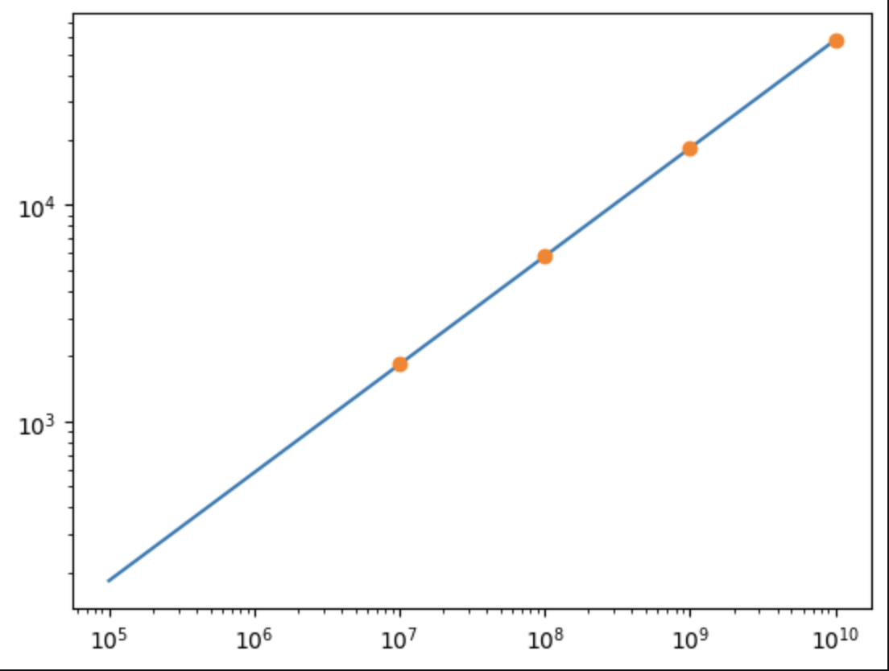

Opgave 6. Signal Path Model
Consider the signal line shown in Figure 1, a simple direct connection between two components.
Unfortunately, this model is too simple and ignorers all the parasitic effects that inevitably are present in this signal line and the components it connects. The task here is to expand on the circuit model and create a more realistic model, which includes the package parasitics given in Figure 2.
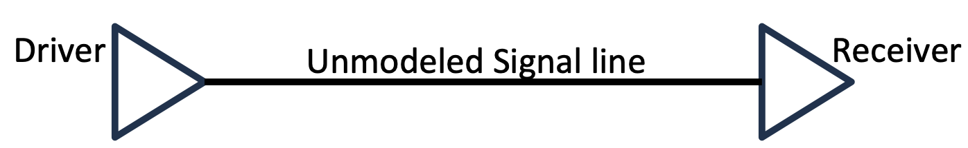
Figure 1. Shows a “simple” signal line between a driver and its receiver.

We are given the following information for the driver:
1.8V logic, 100 ps edge rate, 10Ω output resistance, and 5pF output capacitance.
The signal line can be modelled by a transmission line with $T_{D}=0,5ns$, $Z_{0}=50Ω$.
And, at the very end of the signal line (right before the receiver) sits a 50Ω resister to terminate the line.
The receiver is specified as a CMOS input, with an input capacitance of 3pF.
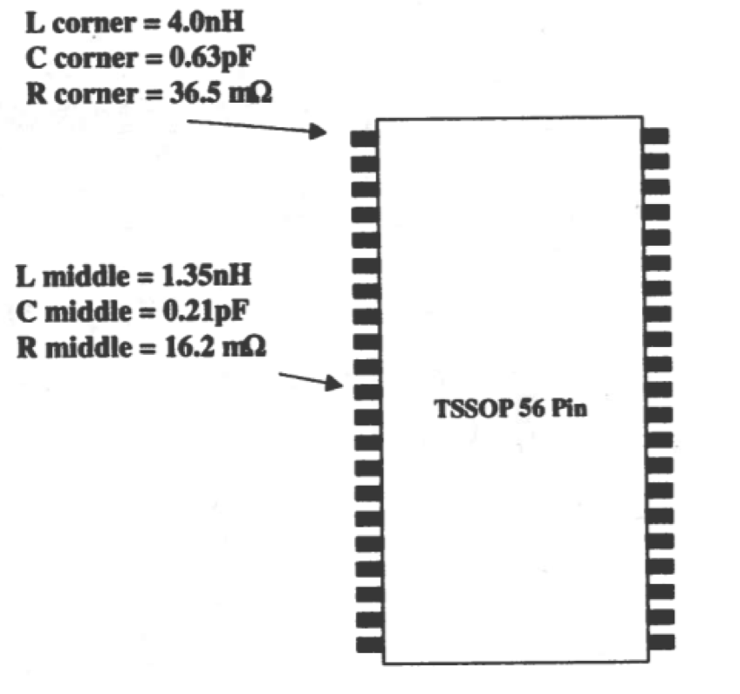
Figure 2. Package with best (middle) and worst (corner) parasitic values shown.

Theory - Specifying the circuit model:
- Design a realistic circuit model of the signal line. Use the best (middle) parameters for the package.
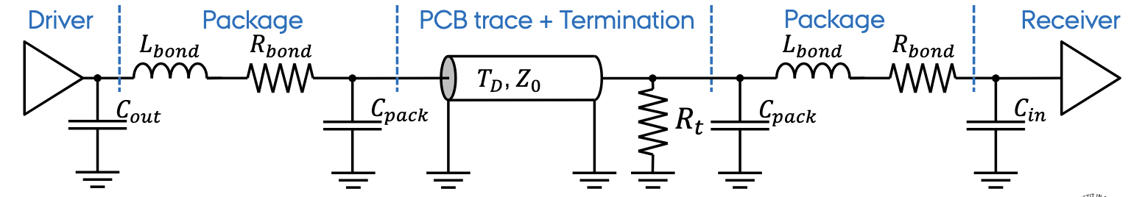

- Design a realistic circuit model of the signal line. Use the worst (corner) parameters for the package.

Evaluation - Simulation
- Simulate the two models created in part 1. (Recommend simulating approximately 5 ns.) Notice the signal shapes, do they look good? Why/why not?
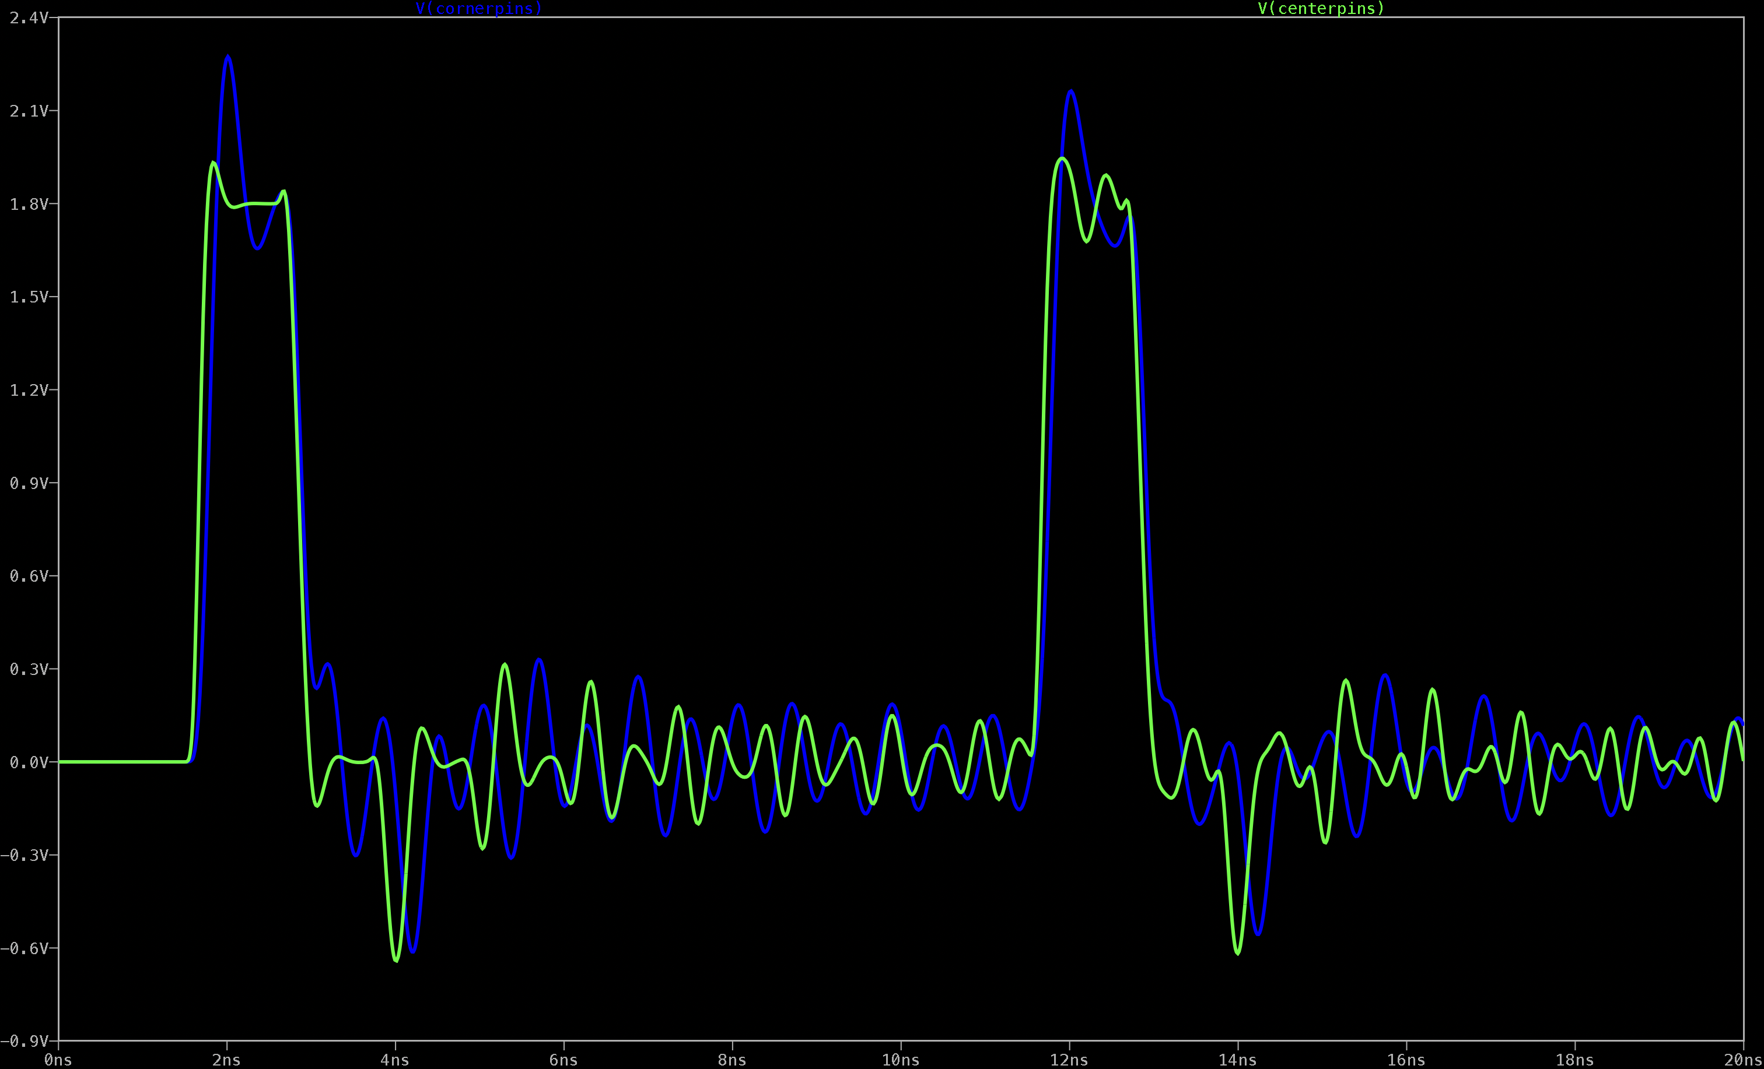

- What about signal timing at the receivers? How do they compare between the two models?
Both models are badly terminated, which causes bounces due to reflections. For a period of 10ns, it hadn’t settled yet, which causes the second period to be distorted by reflections from the first.
It is however seen, that the corner pins stabilizes the slowest and has the highest overshoot.

Opgave 8
In this exercise, we intend to transmit a digital waveform from z=0 to z=l2 through two transmission lines on Board 1 and Board 2 as shown in Fig 1.

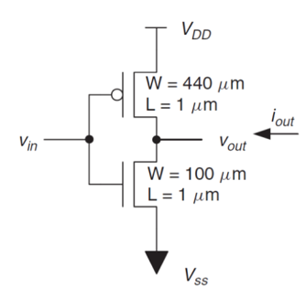
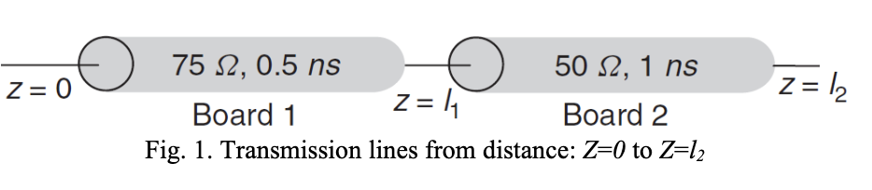
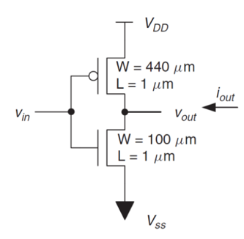

- Construct the i –v curve of the push-pull driver in LTSpice when Vin=2.5 V.
Hint: when Vin=2.5 V, only the nMOS transistor is on. So you should extract the I-V characteristic of nMOS using a DC sweep analysis.

b. Use this to calculate the output impedance of the push-pull transmitter when the load is 75
ohm as in Fig.1.
Hint: Draw the I-V characteristic of 75Ω load with I-V characteristic of the push-pull driver
(nMOS) and find the intersection point

